**EXPERIMENT -1**

**NAME:** MANORATH ITAL

**CLASS:** D15A

**ROLLNO:** 19

**AIM:** Installation and Configuration of Flutter Environment.

Step 1: Go to the official Flutter website: <https://docs.flutter.dev/get-started/install>

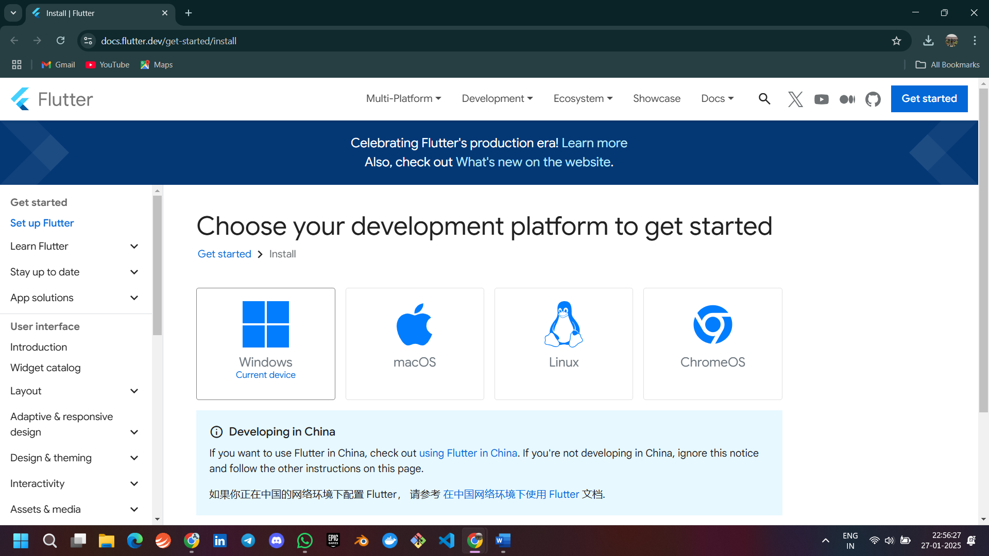

Step 2: To download the latest Flutter SDK, click on the Windows icon > Android

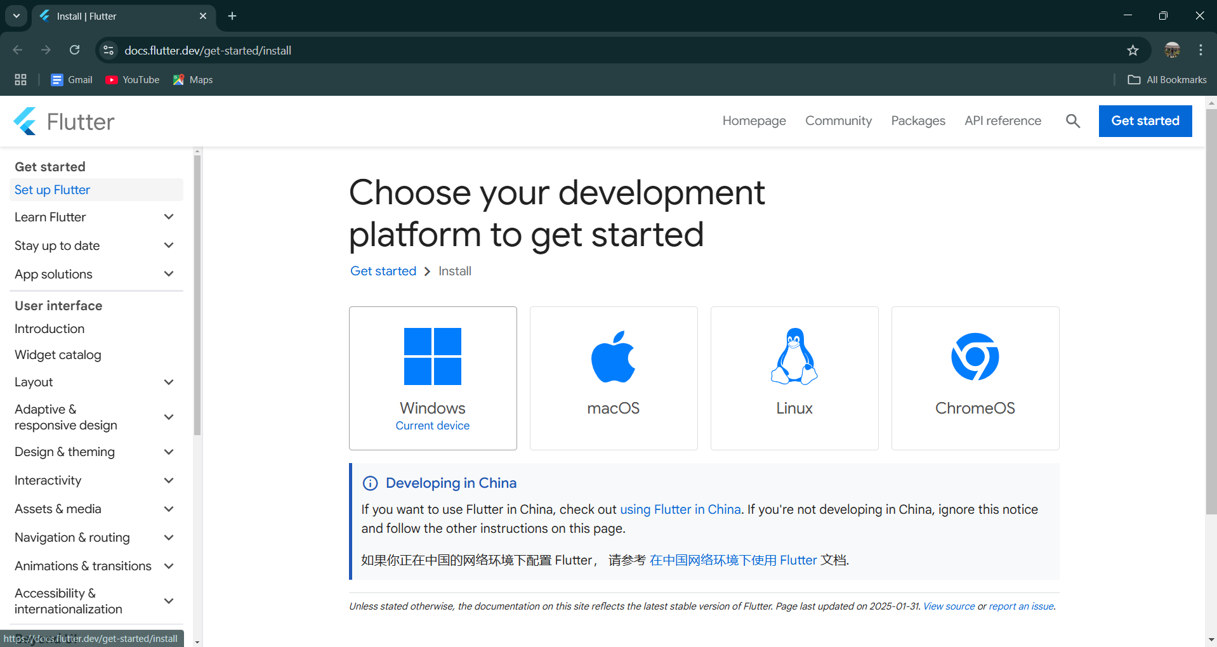

Step 3: For Windows, download the stable release (a .zip file).

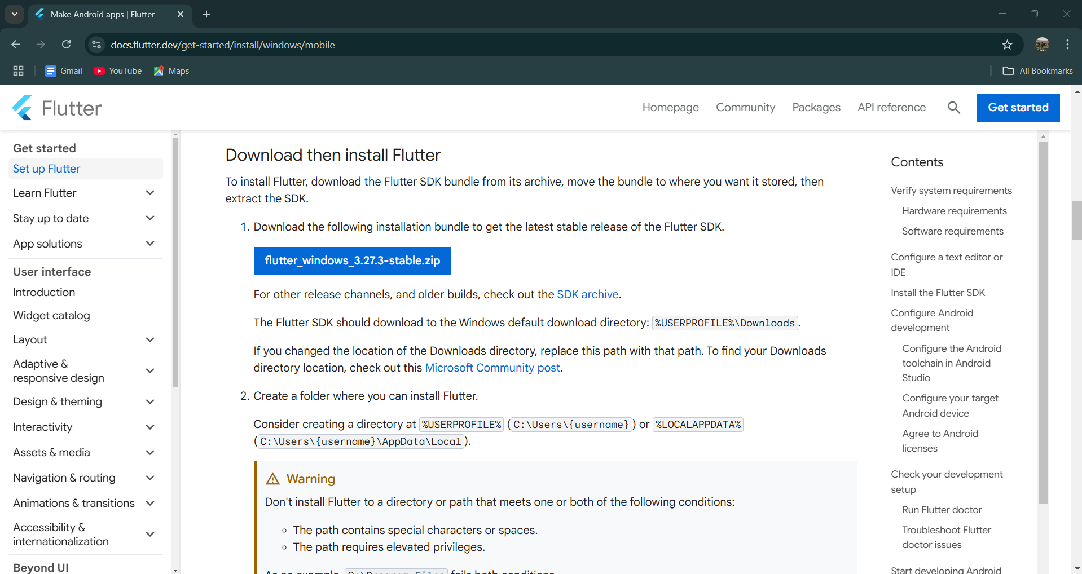

Step 4: Extract the ZIP file to a folder (e.g., C:\flutter).

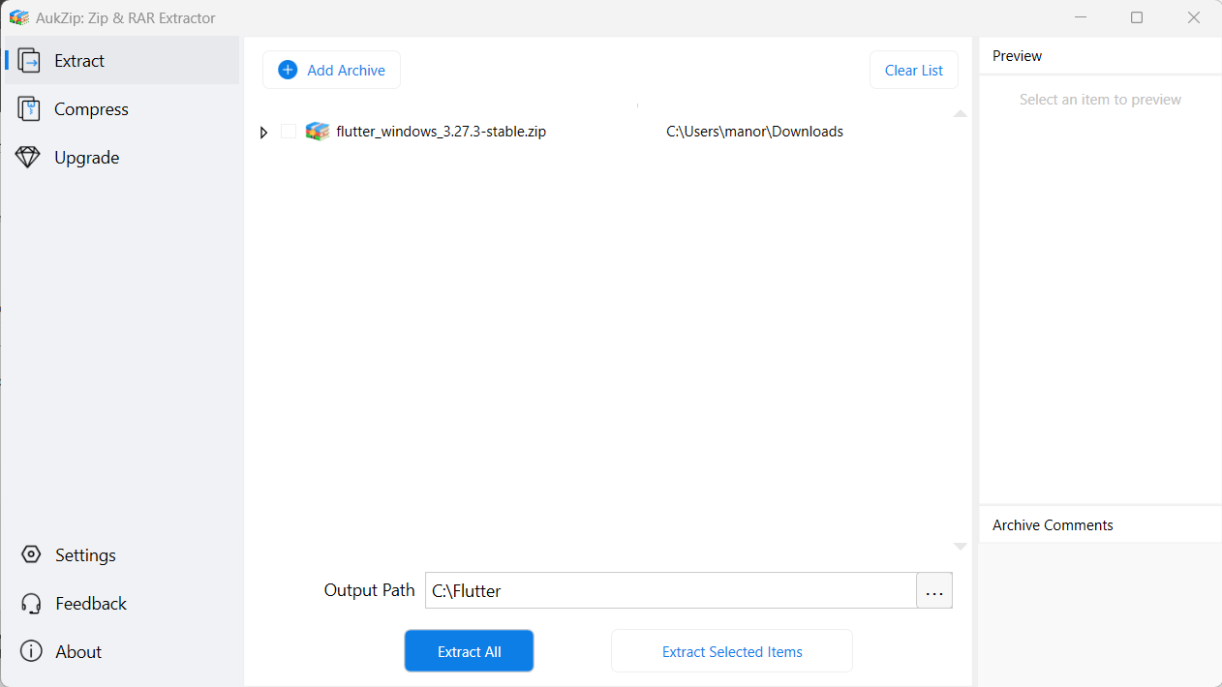

Step 5 :- Add Flutter to System PATH

Right-click on the Start Menu > System > Advanced system settings > Environment Variables.

Under System Variables, find Path and click Edit.

Add the full path to the flutter/bin directory (e.g., C:\flutter\bin).

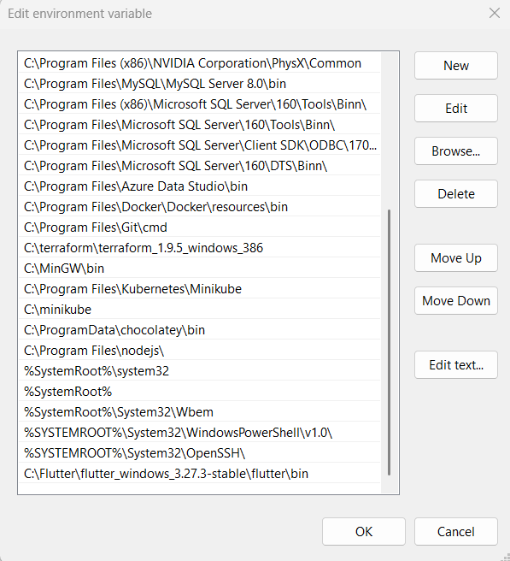

Step 6 : - Now, run the $ flutter command in command prompt.

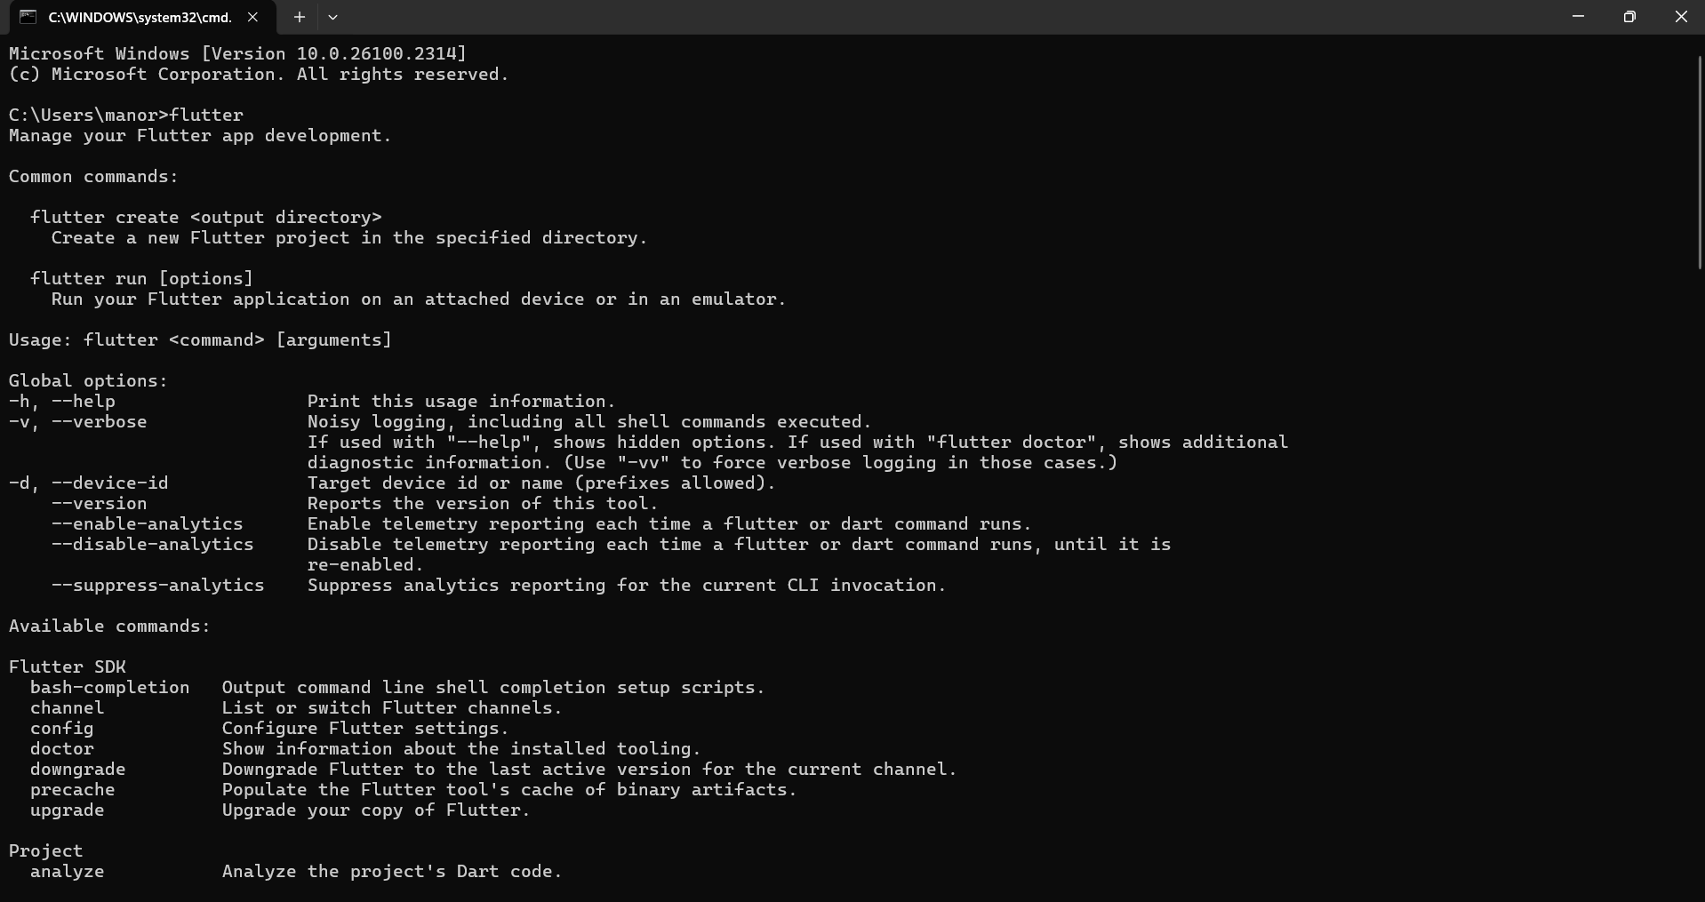

Step 7:- Run the $ flutter doctor command. This command checks for all the requirements of Flutter app development and displays a report of the status of your Flutter installation

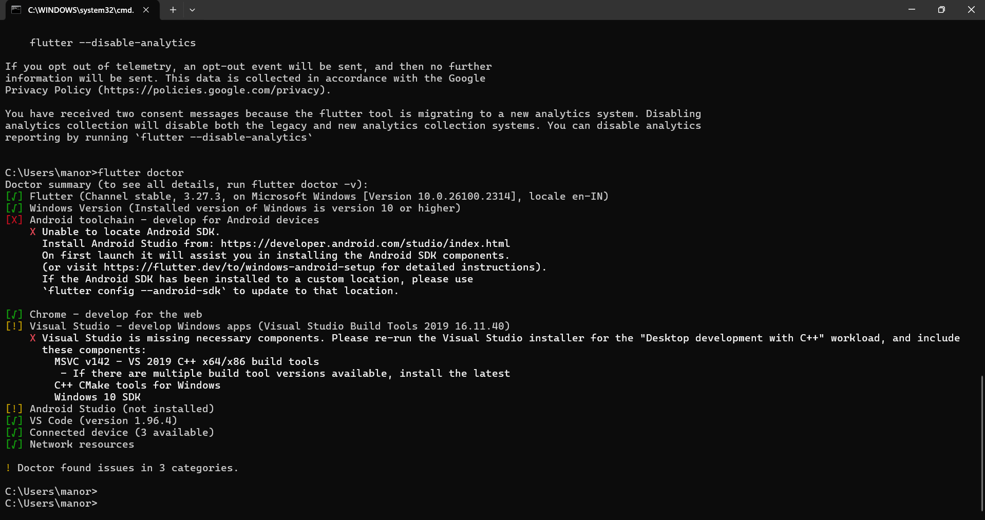

Step 8 : - Go to Android Studio and download the installer.

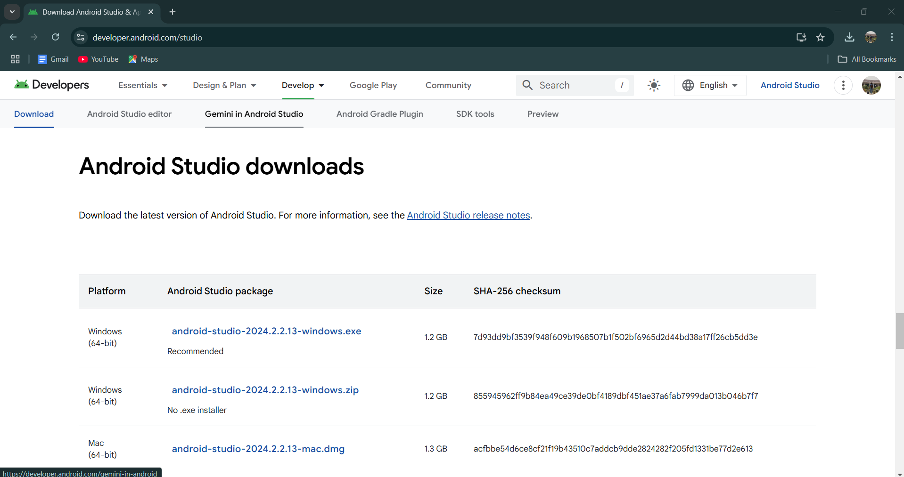

Step 9: - When the download is complete, open the .exe file and run it. Follow the steps of the installation wizard. Once the installation wizard completes, you will get the following screen.

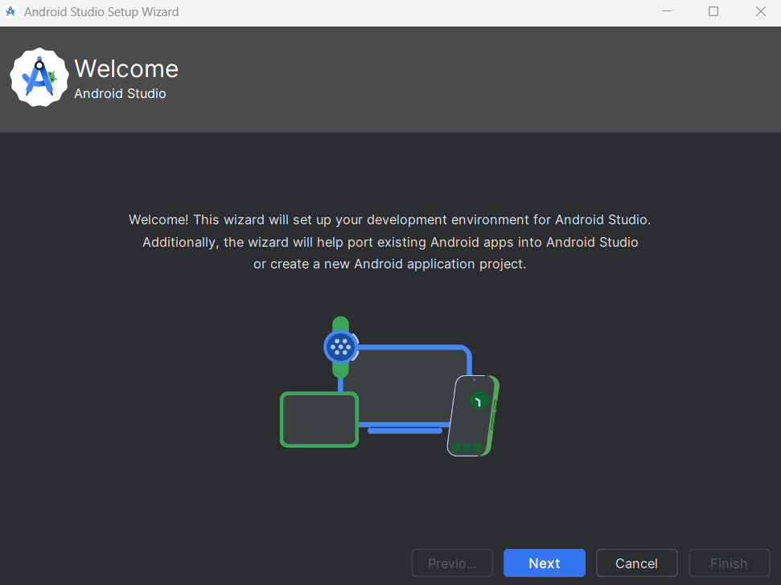

Step 10: - Go to Preferences > Appearance & Behavior > System Settings > Android SDK. Select the SDK Tools tab and check Android SDK Command-line Tools and Install it.

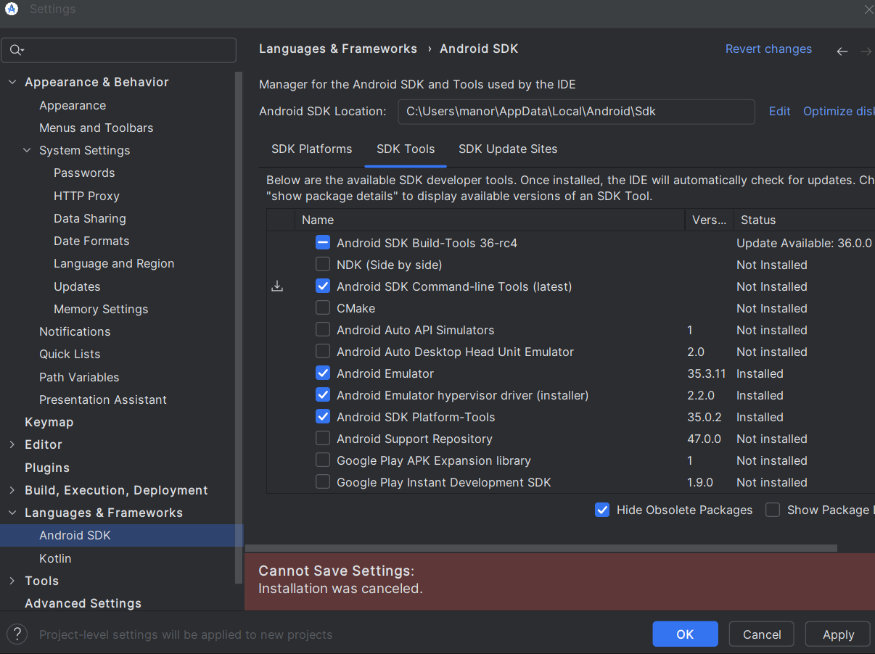

Step 9: - Open a terminal and run the following command

1)flutter doctor --android licenses

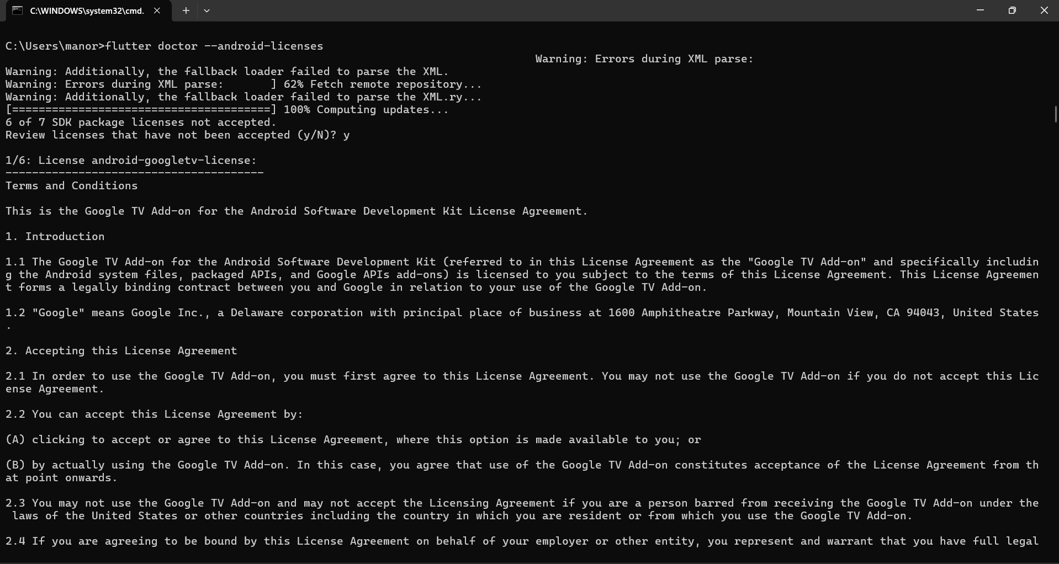

**Accept all the licenses**

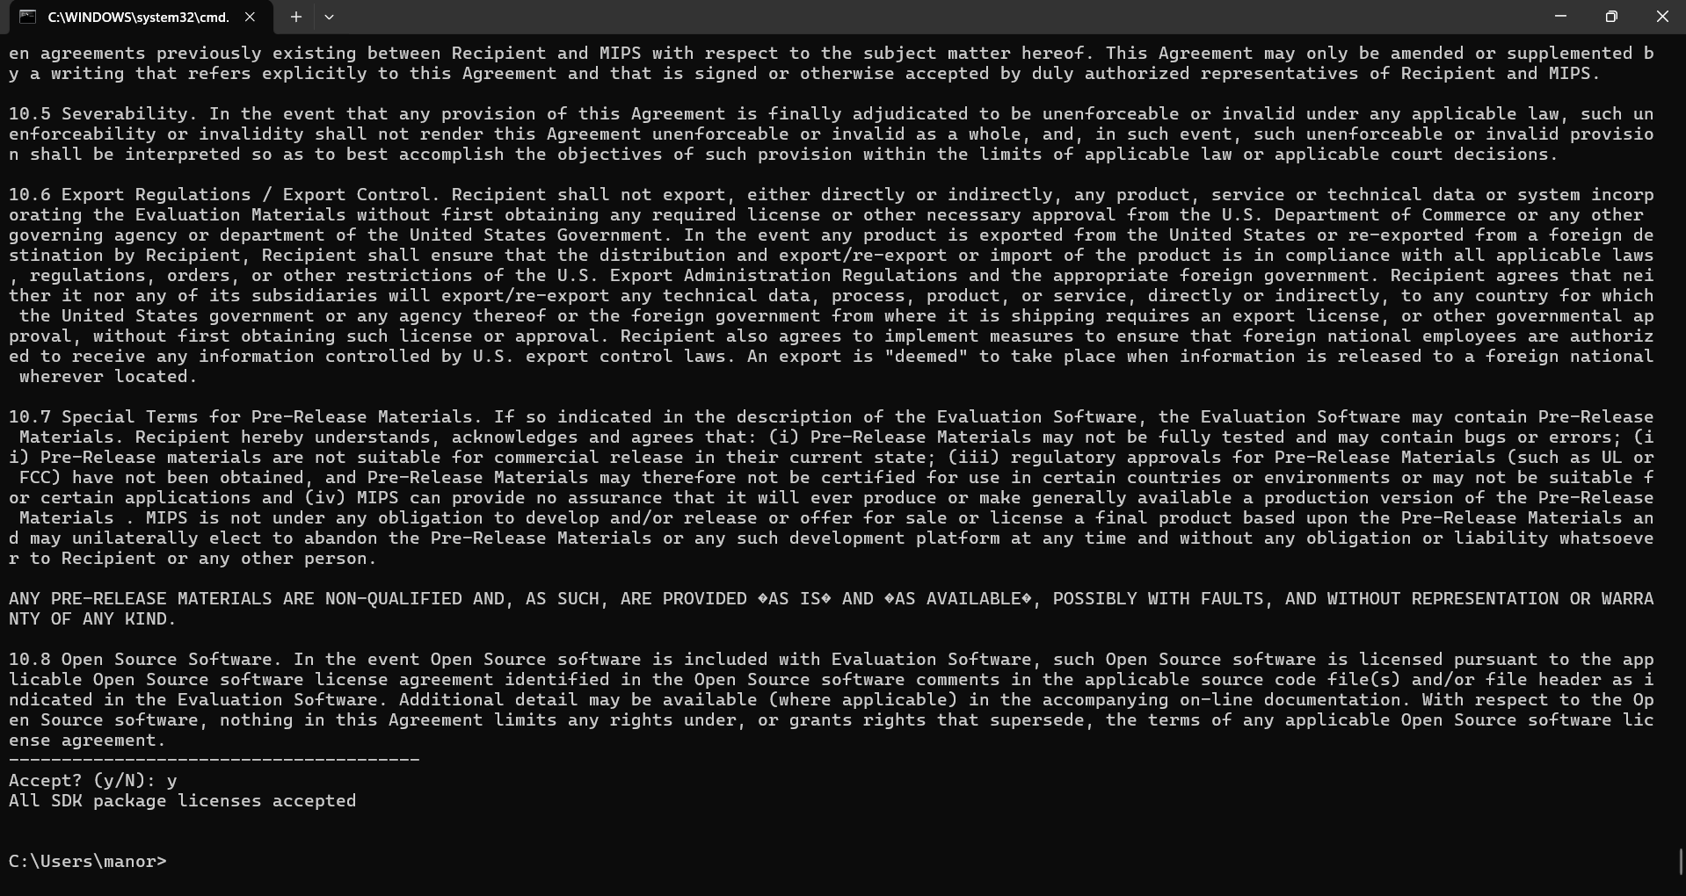

**2)flutter doctor**

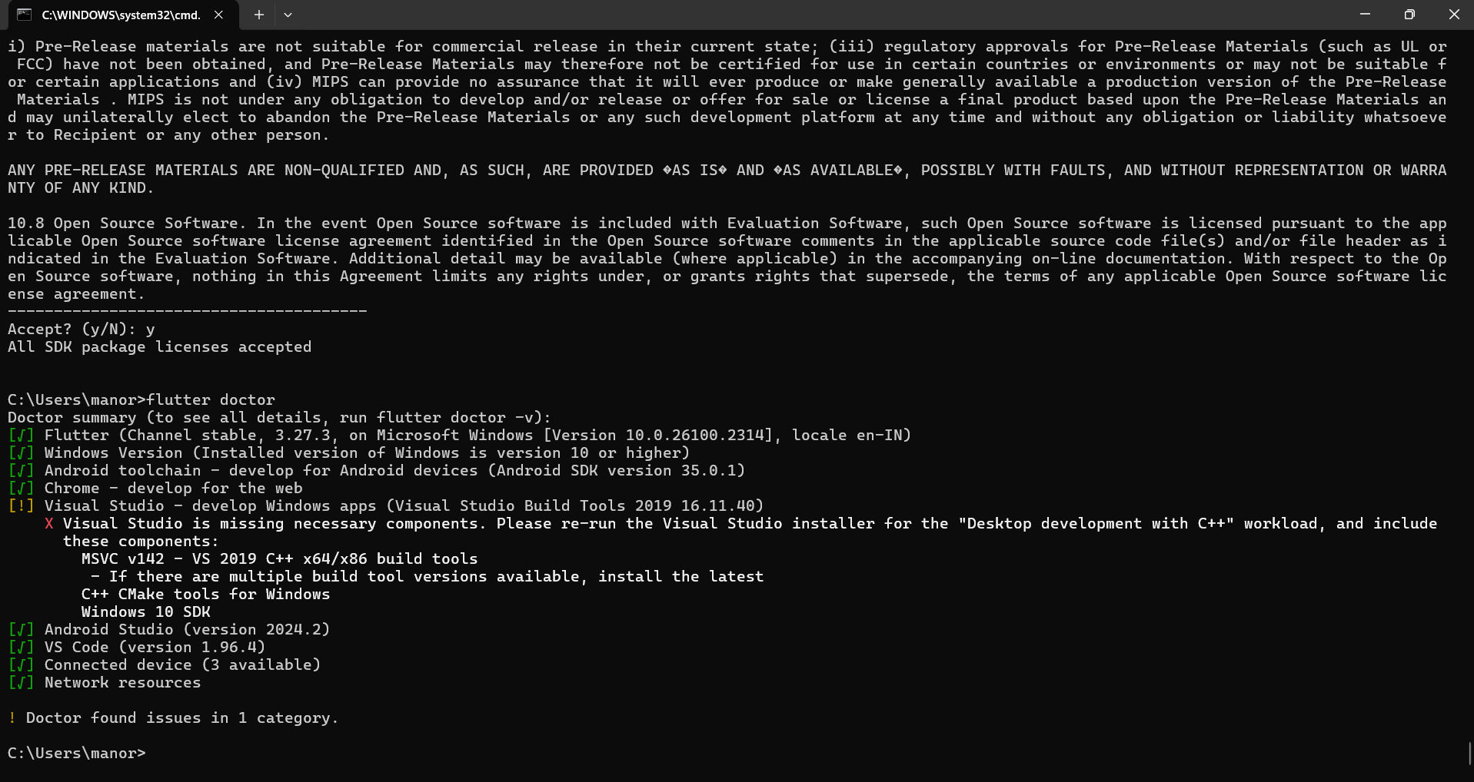

Step 10: - Next, you need to set up an Android emulator. It is responsible for running and testing the Flutter application

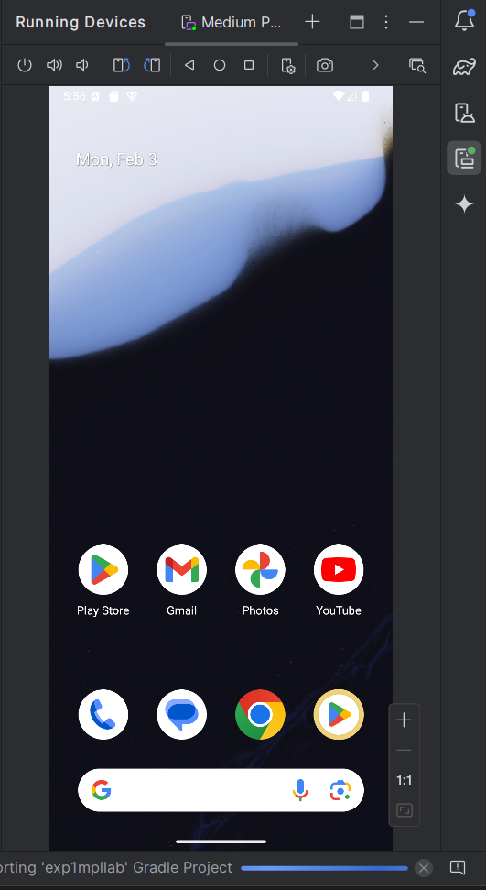

Step 11: - Now, install Flutter and Dart plugin for building Flutter application in Android Studio. These plugins provide a template to create a Flutter application, give an option to run and debug Flutter application in the Android Studio itselfOpen the Android Studio and then go to File->Settings->Plugins. Now, search the Flutter plugin. If found, select Flutter plugin and click install

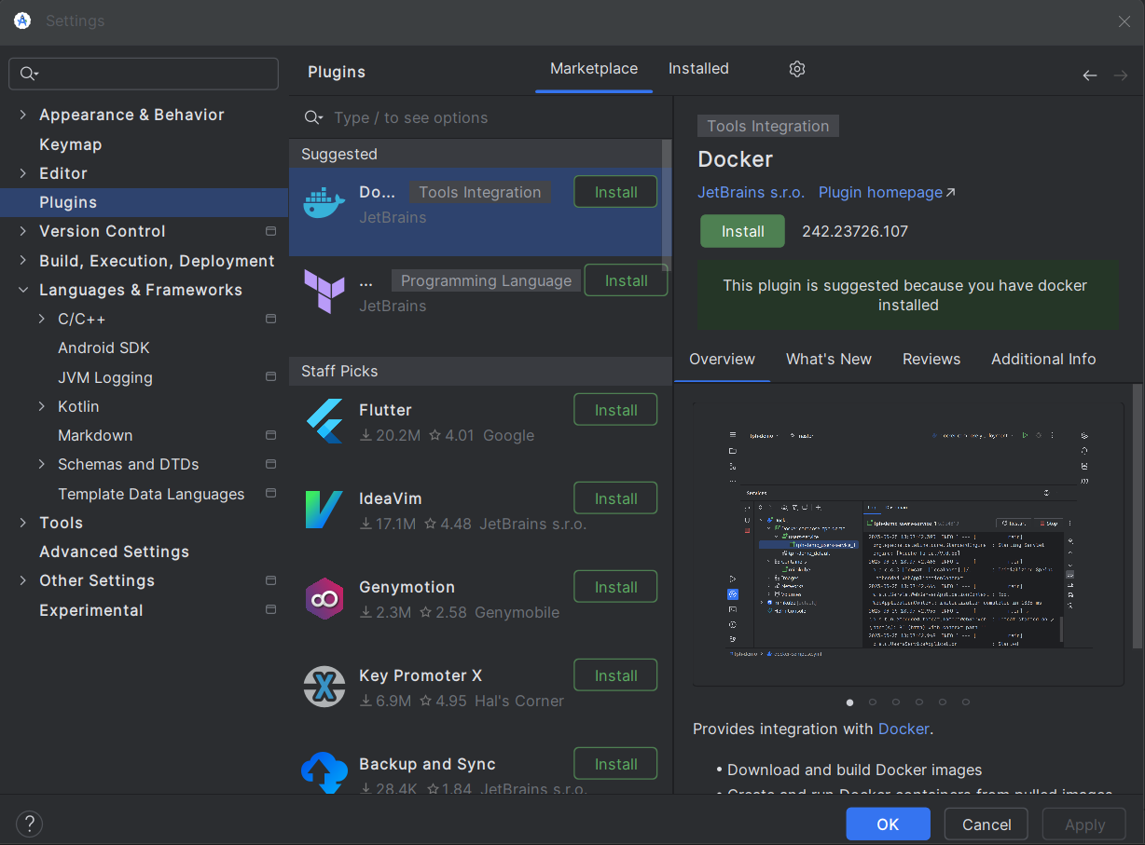

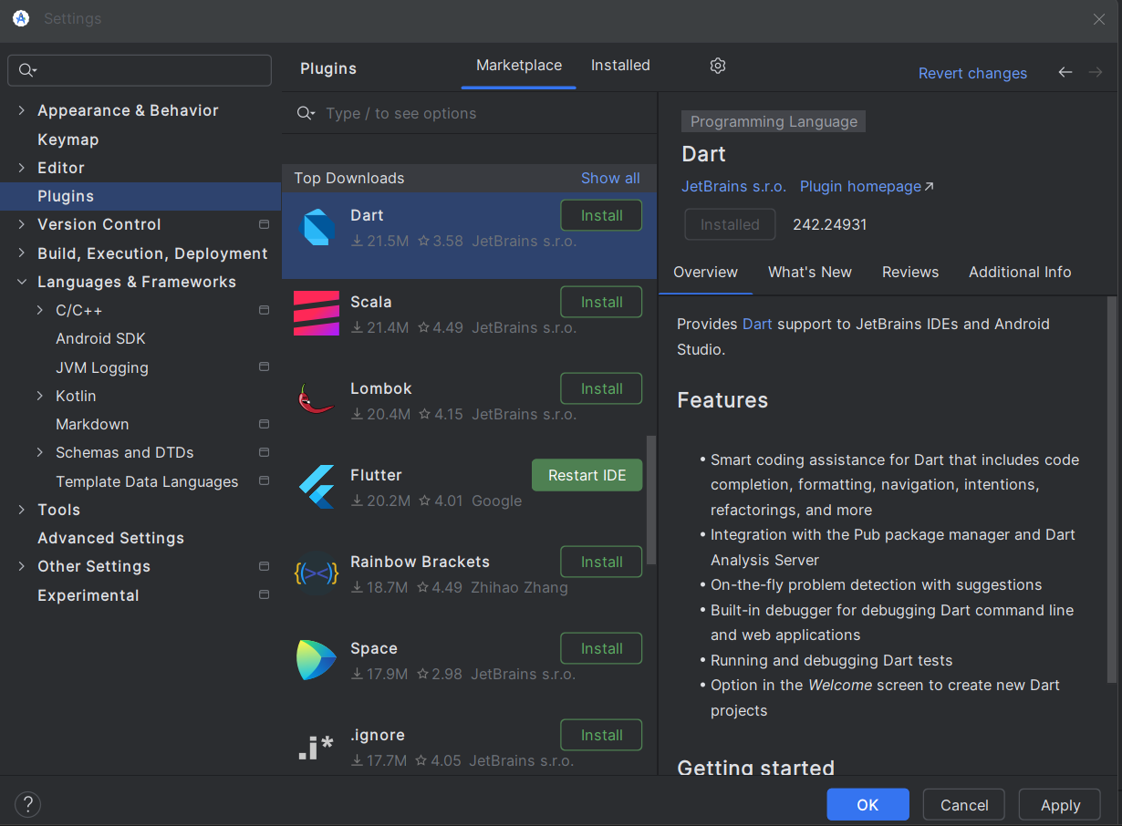

Step 12: - Restart the Android Studio

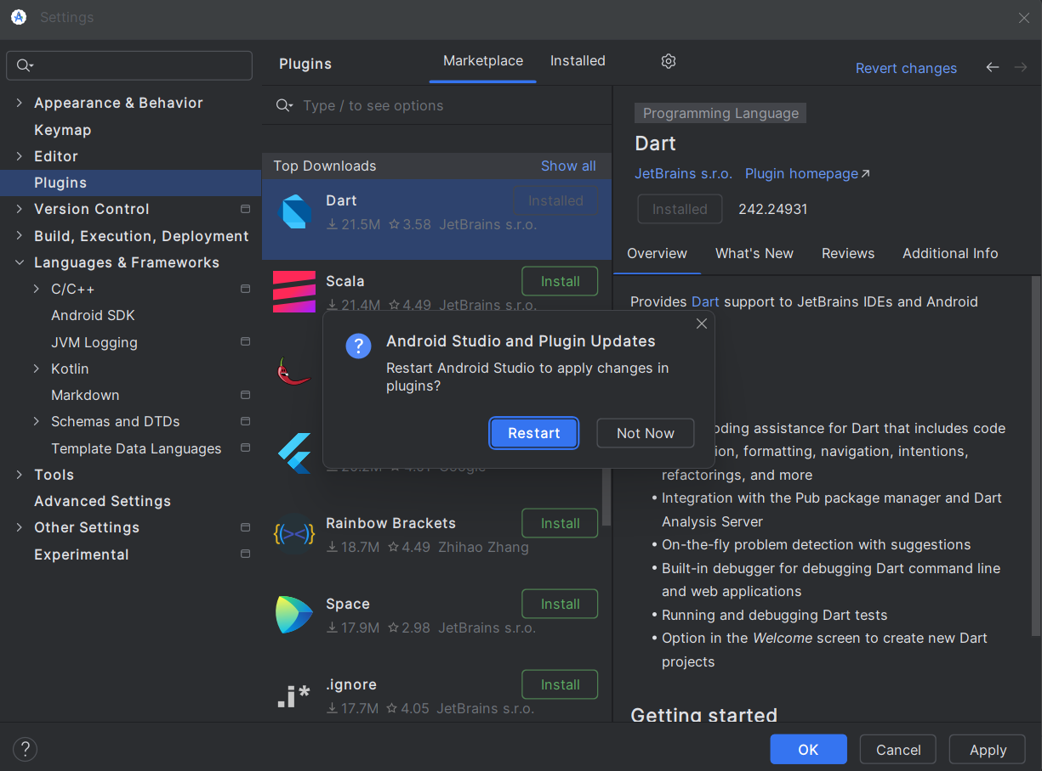

Step 13: - Go to File > New Project > Create Flutter Project, then select the project name and location, and click Next to proceed.

